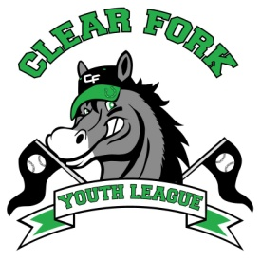
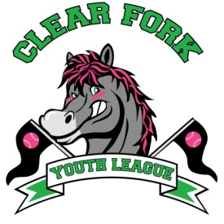
BOARD MEETING
SEPTEMBER 4, 2019
Attendance:
Jay Vail
Allen Leech
Ashley Ludwig
David Myers
Lindsay Roberts
Rick Liberti
Clint Knight

- Clint
  - Gave update on Funnel Cake 5K, 10K, 1M Race
    - Looking for a few more volunteers
    - Jay will make shirts for volunteers
    - Ashley will make coupons for runners for their free funnel cake
- Jay
  - Adult softball tournament will use our fields on Saturday September 7
    - Will open concession stand with a few items for sale
  - Batting Cage
    - AMVETS may be willing to help with cost, Jay will attend their next meeting
    - Jay will get quote for materials
  - Need to get prices for a new 3-wheeler vs attachments for the league’s tractor
  - Jay nominates David Myers for softball president position
    - 2nd by Lindsay
    - Vote is yes

